|  |  |  |
| --- | --- | --- |
| Redesign Document Deco1400 | Coughlins Accounting  Coughlins Accounting | |
| Joseph Ray, s4081775; Adam Fern, s4390072; Ino Ni, s4384885; William Christian, s4384942 | |  |

Introduction

This document contains a site analysis of a small independent business publicly listed as Coughlins Accounting. The following link, <http://www.coughlins.com.au/>, is the home page website for the local accounting firm located in Brisbane. This site is reviewed from the perspective of both a developer and an average user. We record the nature of the content, the way navigation is styled, the overall visual design of the site and catalogue the site's functionality.

After reviewing all of the functions the site provides, we evaluate them against the standards of website development. We do this using a standard web practices scorecard. We detail the results of the scorecard and present them under their own headings.

We then make recommendations and present a redesign to the website, to make a full mockup of the site. We use the previous headings to help in our redesign.

# The Website Under Review

## *Description*

The chosen website is <http://www.coughlins.com.au/>, the online platform for the Coughlins accounting company. They are an accountant and business consultancy company. They provide:

* business and taxation advice,
* audits and assurance service,
* wealth management and financial planning,
* professional advice on superannuation.

The aim of the website from the company's point of view is not only to display an online presence, but also to expand its clientele. It has a firm profile showing their teams, an introduction about Coughlins' services options, and a site for clients getting information before visiting the company. It also provides recently relevant information that correspond with the business; such as, taxation news and business news. Lastly, the website includes a section where they list all the different types of ways that clients and/or potential clients can contact the business.

The aim of the website from a customer's point of view is to provide basic taxation information, and to sell a reliable and friendly accountant. They want to know how to do their taxes, and what kind of service they will receive if they decide to go with Coughlins accounting.

## *Audience*

Coughlins generally target small or medium sized companies and assists them with their accounting problems or provides business advice and management solutions. They provide personal accounting services, superannuation assistance and financial planning services.

The target demographic for this website are people who are in their 30's and 40's who have more complicated tax issues than people in their early 20's. Another major target are people in their 60's and 70's who are leaving the work force and need to consult a tax specialist to find out more about their superannuation.

## *Structure*

The site mate created above gives a rough indication of the general functionality and content for Coughlins website. The website uses two types of navigation in order to perform all its operations; this includes global and local navigation. The global navigation is at the top of the website and can be accessed through all the pages on the website. The global navigation is represented with the yellow font, and the local navigation is represented with the white font.

**Page Descriptions:**

**Home-** This page is the landing page for Coughlins accounting, the content we can immediately see is the contact card in the top right which contains a phone number for both Brisbane and Toowoomba offices. This contact card appears globally on the site. The content unique to this page are the detailed quick contact info on the landing page including postal address, fax, email and ABN. The home page is the only page where the footer appears

**Firm Profile** This contains a large block of text which serves as an “about us” of sorts.

**Our Team** This page contains personal profiles of each accountant working at Coughlins

**Our Services** This section contains a small set of summaries of the subsections is contains. Some of the subsections have local navigation to them, some do not. It also contains summaries of subsections which do not exist, and some headings that are more or less meaningless

**Business and Personal Taxation** Contains two unordered lists of company guarantees

**Business Advice and Management** As above

**Financial Planning** Under construction

**S M S F's** Under construction

**Client Information** This site contains an external links to a legal document and the login section of the site. There are also some links to forms for clients to fill out.

**Monthly Client Newsletter** This page presents a sort of landing page for the newsletters. The newsletter is briefly described and then you are able to link to the current newsletter (hosted on wixmedia) or go to the Newsletter archive

**Newsletter Archive** This page contains a small list of newsletters for clients (all links go to wixmedia) Each newsletter is described briefly with a list of contents and then linked to

**Superannuation** This page contains a giant block of text which might be an embedded PDF without a reader. The page is about 50 A4 pages long and describes Superannuation

**Buying a Business** Contains a short intro to buying a business, at the end of the text is a link going to a docx document about buying a business hosted on Wixmedia

**Forms and Spreadsheets** Contains a list of three forms that should be useful in preparing the return and financial statements hosted on Wixmedia

**News & Publication** Contains an article of moderate length about the Australian dollar

**Business News** Contains a summary of the 2013/2014 budget. It is about 40 A4 pages long

**Taxation News** Contains three small article summaries from 2013

**Taxation News and June 30 Returns** Contains a summary of effects that are relevant to people completing a tax return after 2013

**Contact Us** Contains a list of personal emails, and a Google map locator for both firms, also contains a form for leaving a message

## *Visual Design*

The overall visual design of the site is utilitarian in nature. Every page contains the header bar which contains a single rolling image, the quick contact card and navigation at the top. The words along the bottom are simple text.

The colour scheme used for the website is white and red. Specifically it uses #e07271

The font is treated in Arial 10pt with the heading in 20 pt

Layout-wise there are ten different overall designs that the site uses:

* Home page
* Textual information
* Big text
* Contact
* Login
* Subsection Summaries
* Profiles
* News Archive
* Construction
* PDFlist

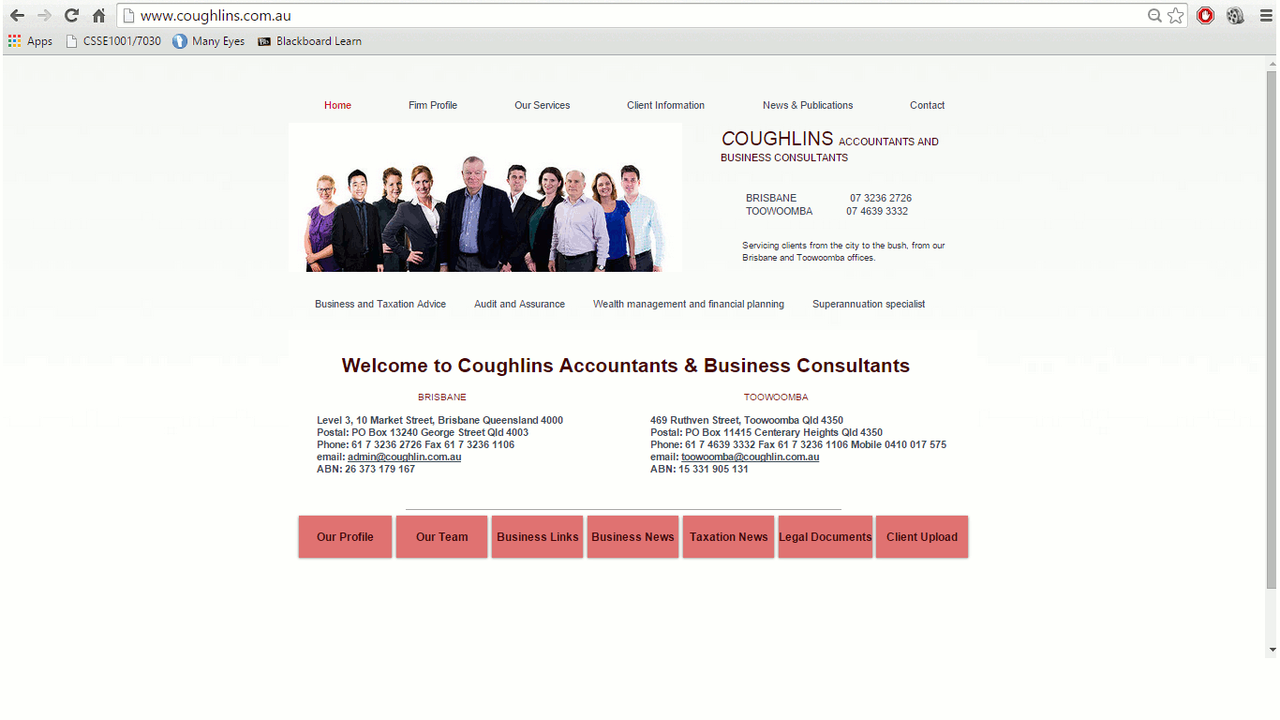Home page design:

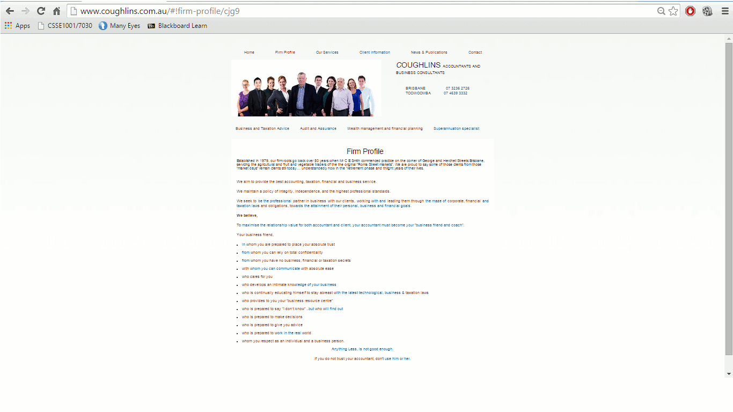Text/Article page

Subsection summaries:

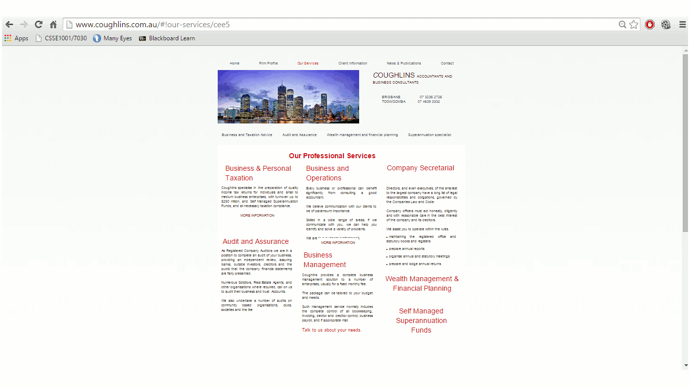

Profiles

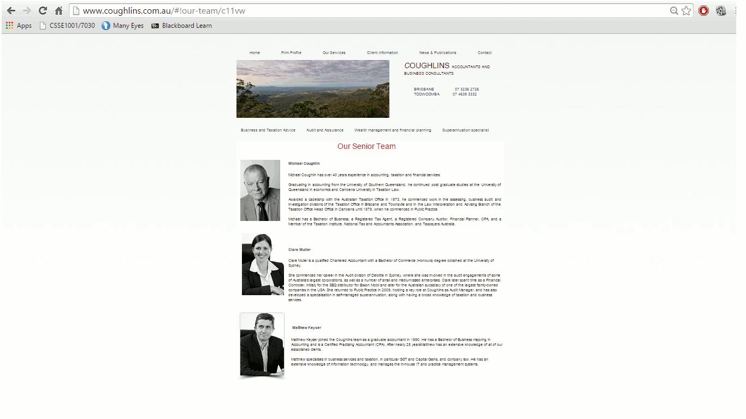

Bigtext page

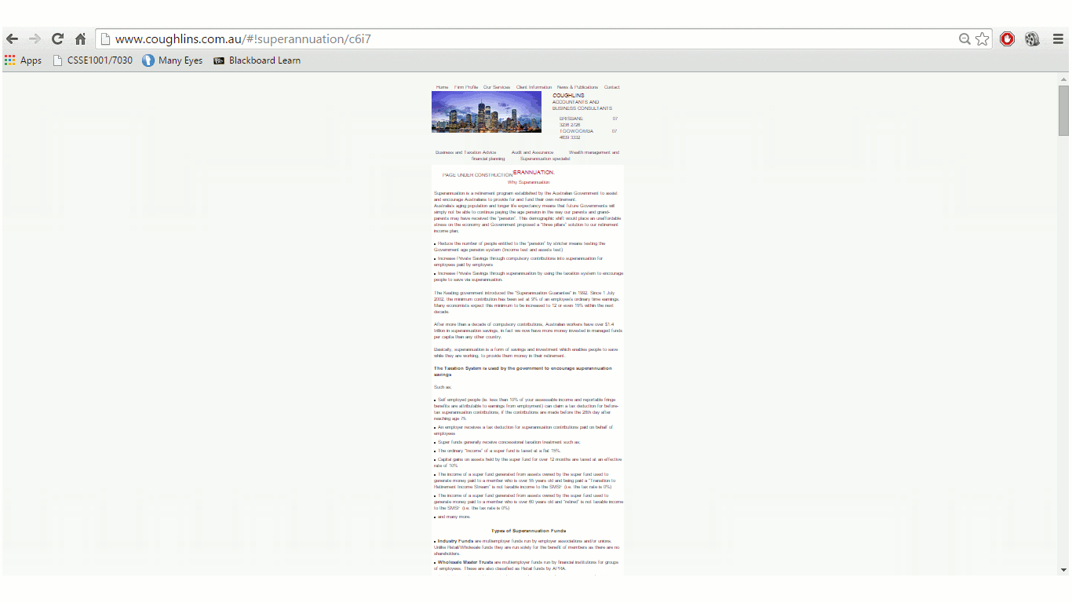

Construction

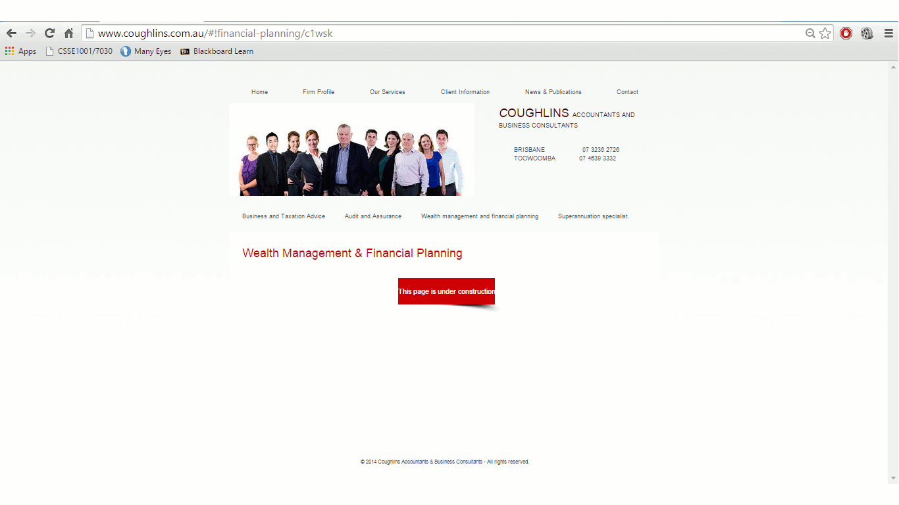

Contact

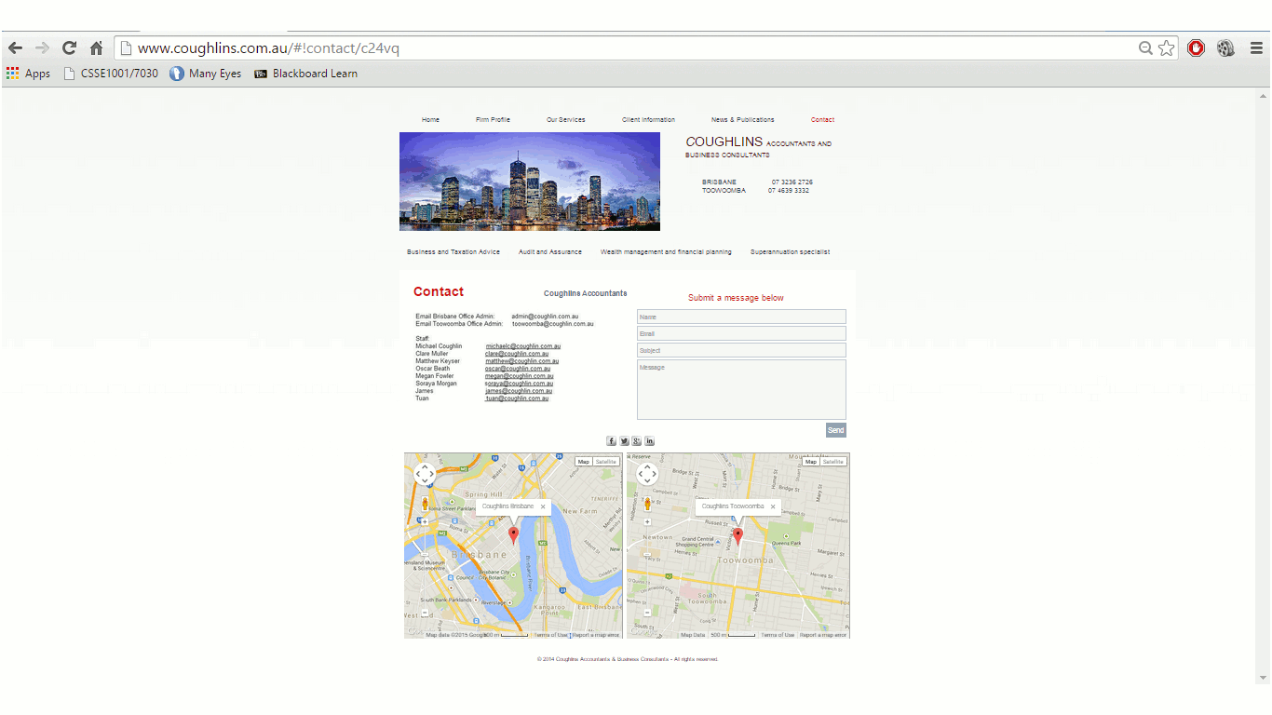

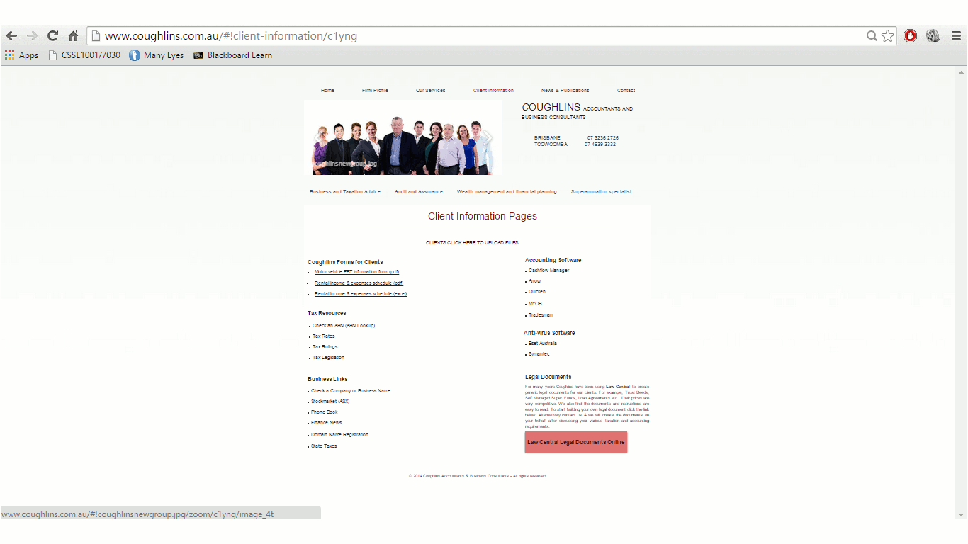Login page

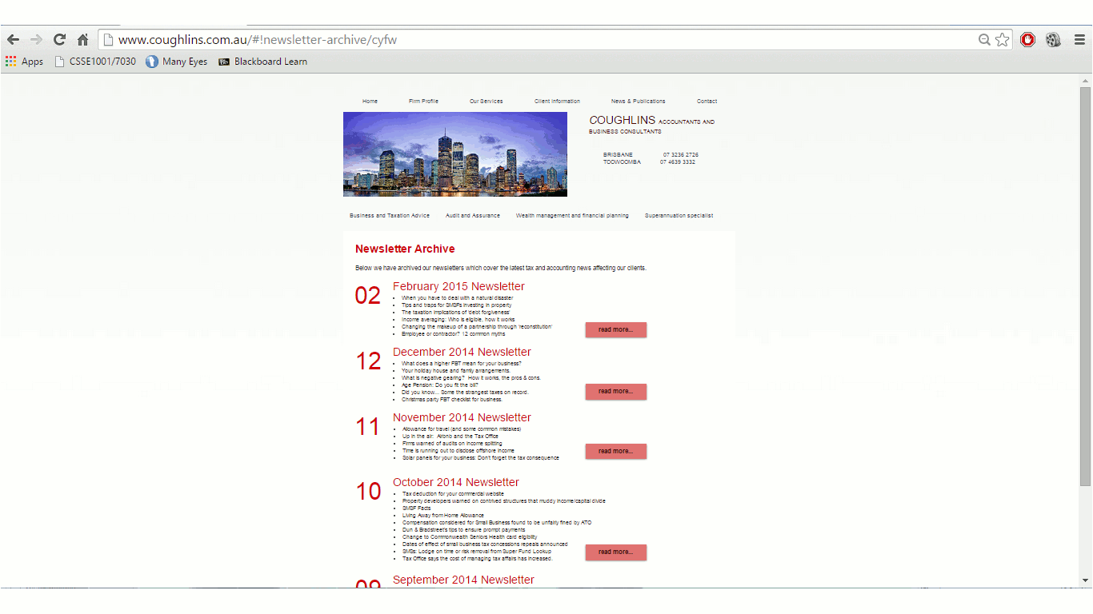Archive page

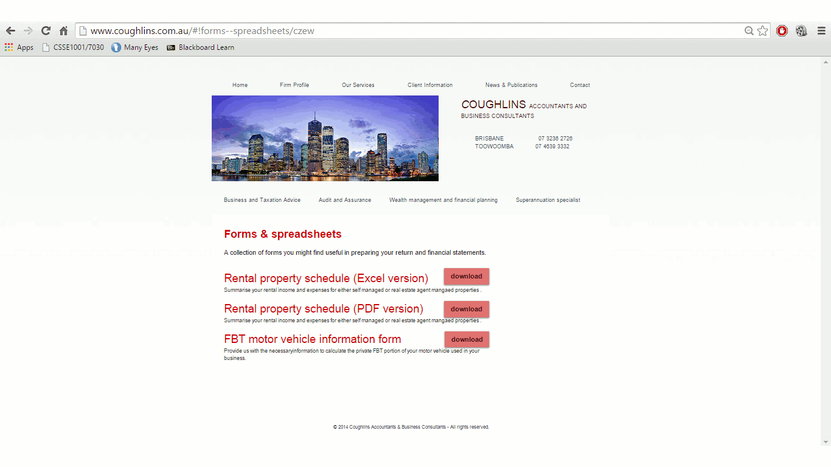PDF Section

## *Behaviour*

This site provides the user with knowledge about their company and their services. It also keeps them up to date with business news. The full list of behaviours a user could expect to perform in the site are as follows:

* Users can log in and drop off their completed forms remotely
* Users can find forms and advice to fill out to assist with their tax returns
* Users can read newsletters published by Coughlins
* Users can use the site to navigate to Coughlins using google maps
* Users can send a quick message to Coughlins using the form on the contact page.
* Users can navigate around the site using the header bar, and on the footer bar of the home page.

## *Functionality*

The site sometimes behaves strangely. For example, there are times when the mouse pointer will change to a hand on rollover but no link will be present. Text that looks like it should be clickable is actually just plain text. All the links work but it's not clear when a link is internal or external because of the heavy use of Wixmedia. Lastly, when clicking the header image it opens up a lightbox that will scroll between the three header images.

In addition, Google maps is used in the contact section, as well as a message form that lets a user leave a message to the Coughlins team. Many links download a large PDF document to your device. Extensive use of JavaScript and inline CSS is present. When navigating between sections, the old section will fade out and the new one will fade in.

# The Analysis Approach & Review

## *Method*

We analysed the website according to the scorecard and made observations along the way. Each team member was given their own heading to manage, and some team members were given two. We each analysed the site and then discussed the analysis together.

* Ino was given identity and page design
* Joey was given content presentation
* Adam was given accessibility and functionality
* Billy was given navigation.

The approach to the evaluation was to consider the website as being used by multiple people. We first considered using the site as someone who is older and hates technology, then as someone who is new to tax, and finally as someone who is comparing Coughlins to a different accountant. Our evaluations reflect what we thought the collective experience of these people would be.

As we evaluated we also made the recommendations to fix the problems that appear in the next section. Doing these steps together seemed more natural than doing them separately.

## *Identity*



Site identity is one of the parts where this site shines.

This header, which appears on every page clearly shows whose site you're looking at; Coughlins, and what they do; accounting and business consulting. The page titles are more than passable, if a bit long winded. One good thing about the site's identity is that COUGHLINS is the only word completely capitalised, and it's in the site's main deep red colour. This generates a sense of awareness to the users and gives the word prominence. As far as section naming goes, it's not clear why “News and Publications” is different from “Client Information.” Therefore, one attribute in the website worth noting is the appearance of the headings (section naming) which appears to be quite dull throughout the website. However, for a professional website about accounting, “clear yet dull” is an advantageous style of design as it meets user expectation. One particularly bad section with regards to section titles would be a customer new to tax and doesn’t possess any knowledge towards the use of abbreviations (e.g. S M S F). The risk that is involved behind using abbreviations is that your assuming users can identify them without doing any research. Therefore, users that don’t know what the abbreviation stands for are most likely to avoid it. The argument could be made that anyone needing to submit an S M S F would already know what it stood for, but there is probably a better title for this heading. The other section names are simply too long and could be shortened.

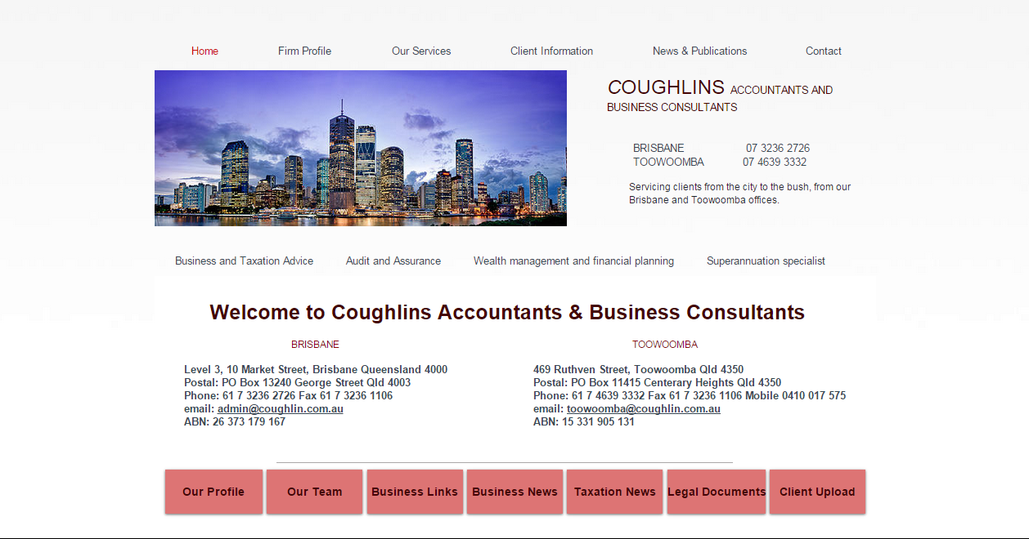The home page is boring. It tells me nothing about the business except where to find them. There's also no reason for the double-navigation that only appears on this page. In addition, the most amount of colour that can be seen throughout the website is on the home page. Therefore, it becomes obvious to users that the rest of the site will consist of similar colour scheme and also highlights to a more tech-savvy user that it is unlikely work of a professional; leaving a negative first impression.

## *Page Design*



Unless you count the fact that black contrasts with white, there is almost no contrast on the entire site. The use of red in the headings (the only colour in the entire site) is not only statistically proven to attract people’s attention, but it also makes for a good heading style. However, on an old monitor and in a dark room red on white can be detrimental to a user's eyes and would make it painful for a user to observe the site in detail.

Some pages have bad alignment, but most are simply justified left within the body. The PDF links all line up which is good. Other complaints about alignment include: some pages have two columns of bullet points where others have one, on the contact page “Coughlins Accountants” appears to have been tab-aligned so it will appear in different parts of the screen on different monitors.

The site is also terrible in its consistency. All the different designs of pages effectively do a single thing, either they present text to the user, or they present a pdf with a description of what's in that pdf. There are currently eight different designs to do this, however should only be two.

When it comes to the balance between text and white-space we get a mixed bag: over the page are two examples, one where everything is spread out too much and another where it’s too close together.

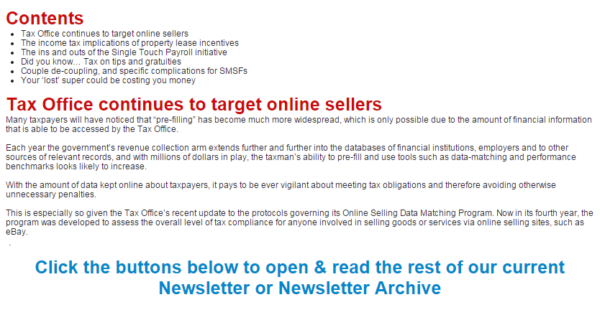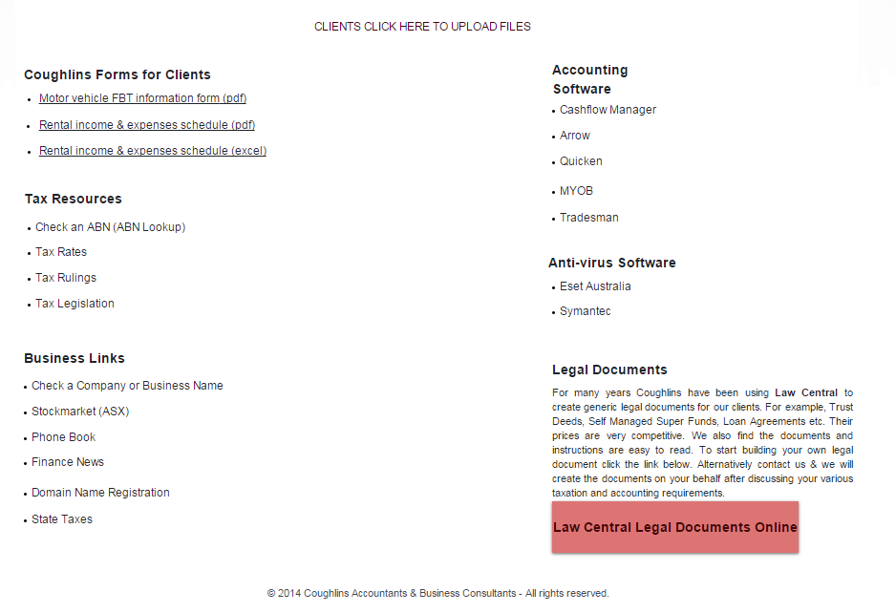

The header takes up ½ the screen at 1024x768 resolution. The only graphics that appear on the site are the graphics in the header, which fail to be relevant (rotating around a picture of Brisbane, a scenic mountain and the employees of Coughlins) and are distracting from the text of the site. The only purpose the graphics serve is to give the site a finished feel, but it's simply a facade when the user looks deeper at the functionality. Most of the site has no proper footer, but where it does appear it does not have any email or copyright information.

## *Navigation*



The only problem with the main navigation is that it appears along-side text which is not navigable:

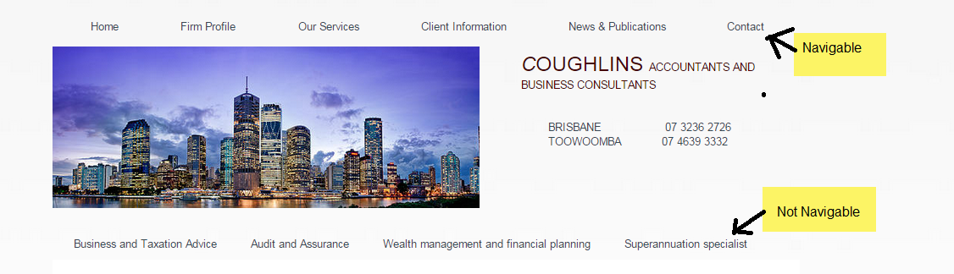Some of the sub headings are not very concise. News & Publications could be shortened to simply “News” or “Publications”, it's not clear why the heading is so long. For the target audience, people over the age of 40 one could argue that they've made the navigation easy by eliminating the need for it. Someone using the site to find the contact details for an accountant would simply need to find the home page where the contact details are clearly displayed. However, for someone who is deciding between two different accountants, they are unlikely to find navigating through sub-menus to find taxation information enjoyable. It is also not obvious that “Client Information” is where a client would login to the website.

When we are in a main heading of the site our position is clear but in a sub heading, the entire heading bar is coloured black.

The entire site uses JavaScript and there are no text locations coded in html at the bottom of the page. The text also does not indicate whether the user has visited part of the site or not. There were a couple instances of “Click here”.

## *Presentation*



Arial is used throughout the site which is a good website font, though it can be a little boring to look at. It is a professional looking font though so it suits the site well. Sometimes the font's colour differs between a darker red and a more vibrant red and it's not clear why.

Bold is used only in headings, but the use of bold for subheadings only on some parts is what downgrades the mark from 2 to 1 as it's confusing and inappropriate. Similarly, some paragraphs are nice and concise, however some pages consist of nothing other than bullet pointed text. It feels like these pages were made purely to raise the page count of the site and could be consolidated.

The content is technical and confusing for the most part. Anybody who is not already an accountant is most likely not interested to read their publications. Some content is good though and seems to summarize major developments for a lay audience.

Unless the only information you want is “How do I contact Coughlins?” or “Who works at Coughlins?” anything else is impossible to find on the site.

## *Functionality*

The site is working and displays correctly on all the major browsers and operating systems. All hyperlinks are functional (though some lead to construction pages). However the major bugbear is the way the site is encoded. For example:

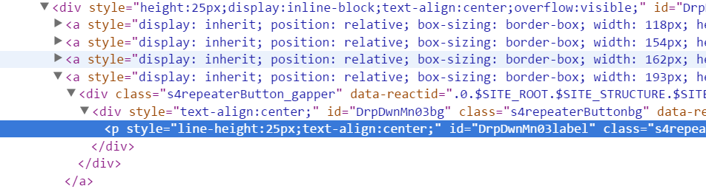is a snippet from the main navigation. Everything is done inline, the CSS, the JavaScript and the HTML. Nothing is done in an external document. Thus the categories is where the site failed.

## *Accessibility*



Colour is simply not used in this website, and where it is used it's inappropriate for the target audience. English speakers interpret red to mean “danger” or “bad” and not “Professional”. The fonts of the headings are easy to read, but next to them the 10-point Arial is hard to read in some of the text body. Black on White is also a glaring combination after a while.

It's not clear why the header images rotate between three images, the images in profile and header have no alt-text. Because the entire site is encoded with JavaScript elements there are really no accessibility considerations in place with this website. The html has no language attribute, and the site is blank without JavaScript enabled.

While page load time is reasonable it should be noted that upon clicking the header the lightbox does not load fast.

# Recommendations

The home page needs to be designed with some actual content in mind. Perhaps having a sales pitch to the target audience. Home page needs a call to action. The header needs to be redesigned so that it's not confusing. For instance, the user should know what text is clickable and what text isn't. If the header is going to change pictures every three seconds, it should either change to meaningful pictures or at least have more than three pictures. Header also needs to be smaller overall.

For page design, looking back at the review we see lots of different ways to display text. We want to consolidate all these different ways into one unified page design. Each page should display one thing and display it well. Text should be consistently spaced. Should add a footer with either a site map or at least copyright information.

Construction pages should be removed from the navigation entirely. No references or links should be made to a page that's incomplete. Client login needs to be more obvious, a login option should be in the main navigation header. Redundant pages should be consolidated into one another (e.g. “Our firm” info should be under “Home”).

A lot of the site's problems with the site's functionality accessibility (i.e. random rollovers, text that behaves like links) require simply ripping all the text from each page and then recoding it from the ground up. JavaScript is overused in this site and could almost be completely removed without any changes to the site's look. This would improve the site from a user's perspective immensely. It would also improve the site from a web-standards perspective and it would allow the use of screen readers.

Finally, the colour scheme for the current website isn’t as fitting for the business as it could be. Black and Yellow could be a great alternative when choosing a different colour scheme throughout the website. These colours promote a sense of success towards the business and also attract people’s attention.

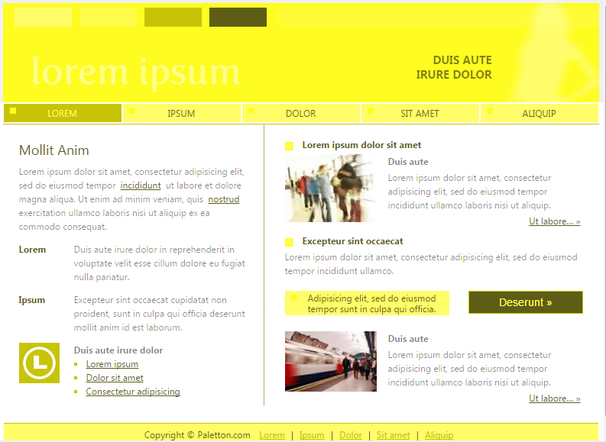

We would also consider using visual props to make the content easier to understand and more relatable. A smiling man who's just had his tax done for example near the text that describes how Coughlins can be your tax consultant.

# Site Redesign

We present here our redesign specification for Coughlins accounting. We start by identifying Coughlins’ key audience, then we condense their individual pages and content into a new site map. We then start the visual redesign with wireframes and mockups of our final product. We then explain our rationale in the next section.

## *Personae*

**Freddy Finances**

“Oh god, when did it become June? Wasn’t it April a second ago?”

|  |  |
| --- | --- |
| Age | 25 |
| Income | 70k-90k |
| Occupation | Lawyer |
| Tax knowledge | Low |

Main points and goals:

* Get taxes out of the way quickly
* Understand more about tax
* Get back to work
* Is new to having to manage his own finances

Freddy recently got a big promotion at his law firm and is now in the firing line for a complicated tax refund. He’s been so bogged down with work lately that he didn’t even notice the passing of time. He thought he’d be fine doing it himself, just like when he was a barista. What he didn’t count on was how complicated tax was going to get once you jumped a couple of tax brackets and you started factoring in deductions and on-the-job benefits.

He just wants to get his taxes out of the way quickly so he can get on with his work. A major sticking point for him though is that he wants to learn more about the recent changes in tax law and wants to know he’s not getting screwed over by an untrustworthy accountant. He’s savvy when it comes to legalese and reads all the fine print on every document, always looking for the “Catch”

**Mister Moneybags**

****“The only thing better than deductions… is being rich!”

|  |  |
| --- | --- |
| Age | 56 |
| Income | 150,000 |
| Occupation | Landlord |
| Tax knowledge | Moderate |

Main points and goals:

* Has been a landlord for a long time.
* Used to use an old friend to do his accounting
* Knows a little bit about taxes, but needs more up-to-date information
* Wants to understand modern taxes to get the biggest refund he can
* Wants to win the next beauty contest
* Is switching accountant, wants to find the cheapest price

Mister Moneybags has been around for a while. He’s not new to the game and prides himself in being able to see a charlatan from a mile away. He wants to get right down to business. His tax needs are complicated, involving old estates, income from rental properties and income from random sources.

While he prefers to talk in person, he really wants to scope out his new accountant before he settles down. He’s most likely to explore the whole website and assess the accountant’s knowledge and acumen before settling down on one decision. He hates spending money where he doesn’t need to and will haggle over price until his face turns blue.

**Jack and Jill Jones**

“Now that we’re small business owners, tax just got a whole lot more serious

|  |  |
| --- | --- |
| Age | 35 |
| Income | 75,000 each |
| Occupation | Grocery store owners |
| Tax knowledge | Non-existent |

**Main points and goals:**

* Just started a new business this year
* They want their finances managed externally so they can focus on their business
* They are more willing to trust somebody with experience
* They don’t know what they’re doing

Jack and Jill just opened a new grocery shop. They weren’t expecting the amount of forms they’d have to fill out as business owners and need a hub of information for new business owners. They found ATO.gov.au was too impersonal and want a more personalized approach to tax. They want everything condensed to “sign here, here and here” so that they don’t have to worry about how much they’re paying the government.

They want to capitalize on any government initiatives for small businesses. Being new business owners though, and being the owners of a small business they have no way of knowing what deductions or benefits apply to them. They want to learn more about the Australian taxation system but want a website that is specific to them and their needs.

## New Site Map

The site map created above gives a rough indication of the general functionality and content for Coughlins website. The website uses two types of navigation in order to perform all its operations; this includes global and local navigation. The global navigation is at the top of the website and can be accessed through all the pages on the website. Lastly, global navigation is represented with the yellow font, and the local navigation is represented with the white font.

**Home Page –** This page is the main page for Coughlins Accounting’s website, there is a contact detail on the top right of the website which contains a phone number for both Brisbane and Toowoomba offices. This contact Details is appears globally, it works also for the footer of the website.

**Our Offices –** Information about the Coughlins’ offices

**Firm Profile –** This page contains a paragraph. It similar to “About us” page for every website. Also, contains a short vision of the company.

**Our Team** - It contains the teams of Coughlins Accounting’s company.

**Our Services –** This page contains of links to Business & Personal Taxation, Company Secretarial, Audit & Assurance.

**Business & Personal Taxation, Company Secretarial, Audit & Assurance –** Information contain a paragraph of explanation about those topics.

**Clients Area –** This page contains a link for clients to upload their files, legal documents, and accounting software inside coughlins

**News & Publication –** Contains an article of moderate length about the Australian dollar, and other information such as budget report, latest taxation news, 2013 changes to tax, and monthly client newsletter

**Contact us –** Contains a list of contacts, maps, and a text box for users to fill it out.

## Visual Redesign

## *Colour Scheme*

## 

The new dominant colour that was implemented into the redesign of the website was yellow and also known as hexadecimal value #FFD901 (shown above). The use of yellow in a website allows for a more engaging page and portrays a desired business feel for Coughlins Accountants. The colour yellow also accentuates wealth and gives off a positive and wealthy impression. Moreover, the colour is very eye-catching and distinct. For the redesign, yellow is used in both the websites upper body background and the footer section.

The secondary colour used is black and has a hexadecimal value #090909. The colour black is quite stand out when accompanied with the background of yellow, as it provokes a sense of class and sharpness. The website of Commonwealth Bank and JB-HI-FI are great examples of these colours being used to showcase their businesses in a professional manner. The black colour is used in the company name and navigation bar, also for all text on every page.





Other colours are white with hexadecimal value of #F9F9F9 and light yellow with hexadecimal value of #FFFA8D. White is the text colour for navigations as well as the background colour for main body text. Light yellow is used for decoration and colour transition. When hovering over the navigation button, the button turns to light yellow with text turns to black and bold.



## *Text Treatment*

|  |  |  |
| --- | --- | --- |
| Site Text | Font Treatment | Example |
| body | **Color:** #090909  **Font-family:** Arial  **Font-size:**11px  **Font-****weight:** normal | Business and Taxation Advice |
| h1 | **Color:** #090909  **Font-family:** Georgia  **Font-size:**21px  **Font- weight:** normal | Business and Taxation Advice |
| h2 | **Color:** #090909  **Font-family:** Georgia  **Font-size:**18px  **Font-weight:** normal | Business and Taxation Advice |
| a:link | **Color:** #F9F9F9  **Font-family:** Arial  **Font-size:**15px  **Font- weight:** normal  **Background:** #090909 | Business and Taxation Advice |
| a:hover | **Color:** #090909  **Font-family:** Arial  **Font-size:**15px  **Font- weight:** bold  **Background:** #FFFA8D |  |
| a:active | **Color:** #090909  **Font-family:** Arial  **Font-size:**15px  **Font- weight:** bold  **Background:** #FFFA8D |  |

In the redesigned project, text will be justified to both left and right. The news page will be aligned by time. The introduction of each news will be displayed below, allowing users to scan through and find useful information. Each section is followed by a “read more” link to view the whole news. Example is attracted below from http://www.adriansca.com.au/news-events.

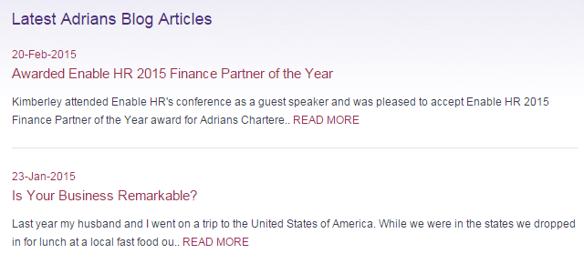

## *Image*

There are more images added in to attract and navigate users. A contact us button showed on the header section with hyperlink to “contact” page. Further, the logo picture appears at the footer section with transparent to the yellow background.

 

The three cycling images in the home page will be replaced by a singular image of three staff members. 

Colour photos in the team profile section will replace the black and white photos to stop them looking ancient and boring. Also, the constant use of borders will be used throughout the photos and will avoid the previous inconsistency (of borders) that was present.

## Wireframes

Home Page

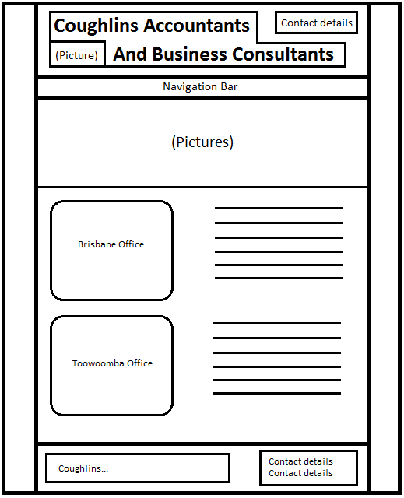

Firm Profile Page

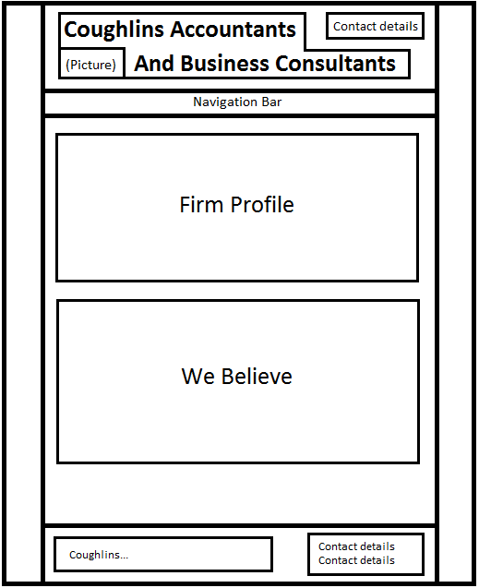

Our services Page

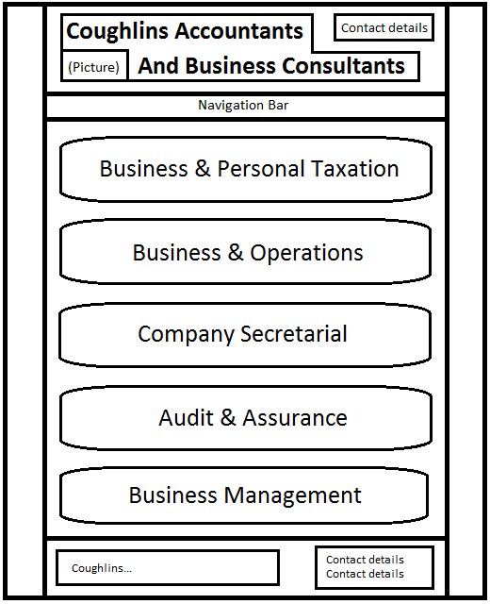

Client Information Page

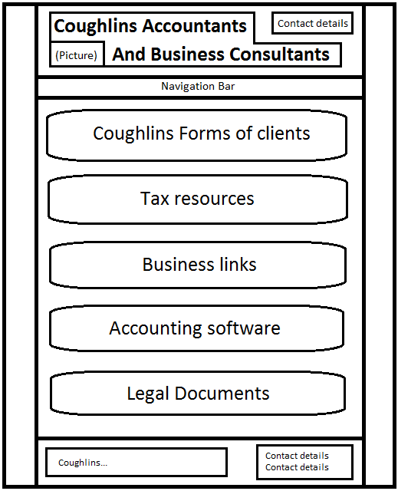

News and Publication Page

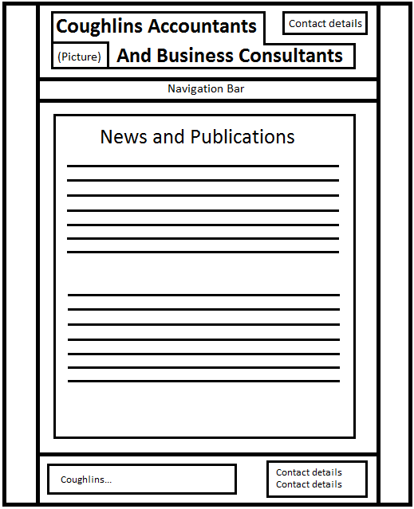

Contact Us Page

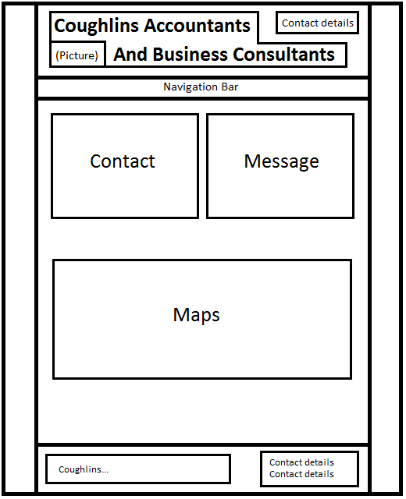

External Links

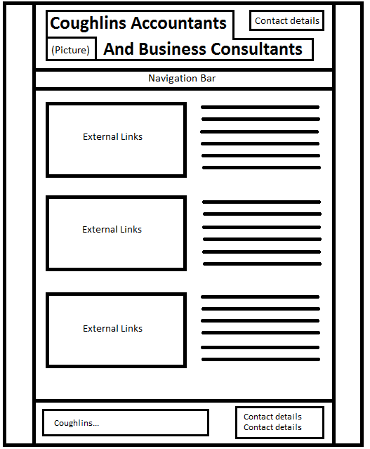

PDF’s

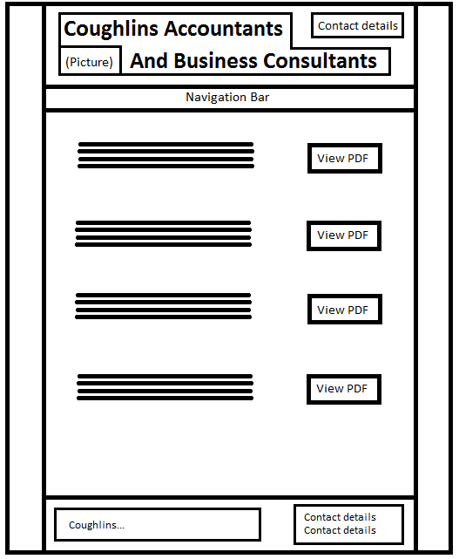

## Functionality

The new redesign of the site will attract a variety of different customers. These customers are broken up into three personae's and have helped aid in the correct redesign for the website. The redesign of the website will ensure that the functionality is compatible with the three personae’s and that simplicity also ties in with them.

The layout of Coughlins website went through a variety of different changes. These include; downloading a pdf, submitting a contact form, changing the way users navigate around the site, and making it clear what the user can select in the site. Previously, downloading a pdf became difficult for the user when they were forced to a different source and had to download it off a different database. To make this a more pleasant experience for the user the pdf should be located within the website; avoiding confusion on where the document came from.

In addition, submitting a contact form online to the website will be done differently. Previously, the forms would be submitted through interacting with a foreign source. However, the redesign of the site will ensure that this is done just by simply uploading it the local database within the site.

Lastly, the way users navigate around the site and can click on broken text has also been a major topic for the functionality of the website. In the previous/current design for Coughlins accounting website they haven’t made it clear which text in the website acts as hyperlinks; as a result the users are left confused and frustrated. The redesign of the navigation in the website ensures that the users won’t have any issues when it comes to finding their way around the site and that they will be able to tell the difference between a hyperlink/text.

## Mockups

Here is a blank page where we demonstrate the overall page layout. The footer section only appears at the bottom of the page, but the header is locked to the top of the browser so that navigation will follow the user as they scroll through the page.

The page is optimized for viewing at 1024x1080 and the navigation bar is 1000px across, thus framing the site. The unused area at the side is a thick grey to offset the brightness of the yellow and to differentiate the body area from the rest. We will remove the footer and background grey from future screenshots, but they will be present on the final product.

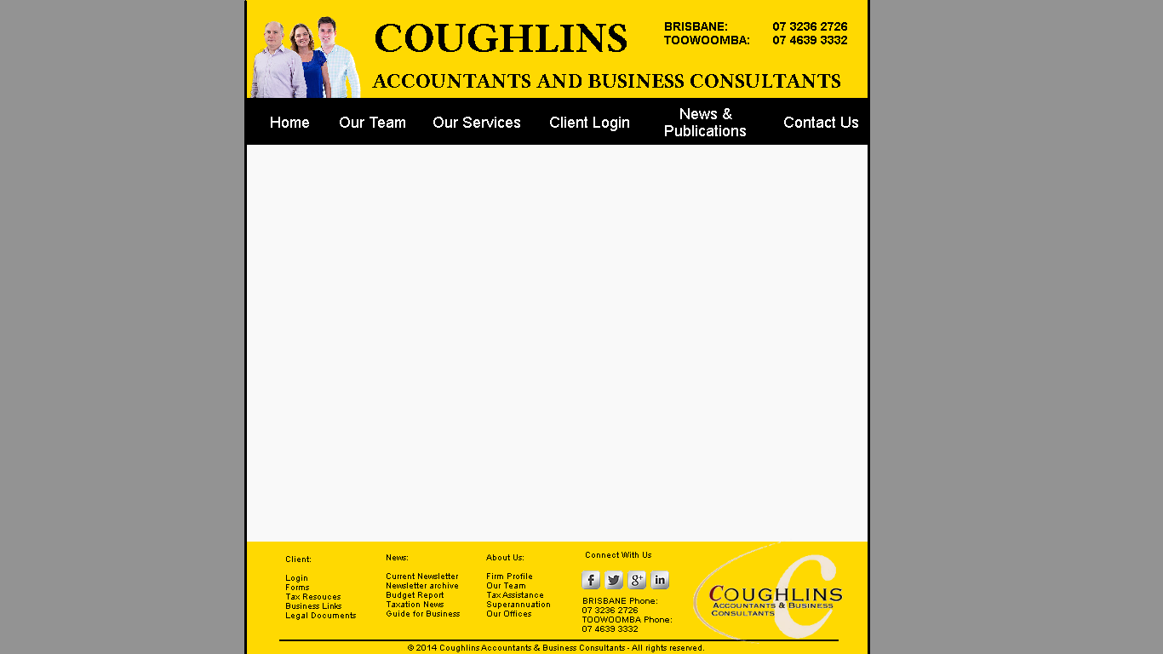

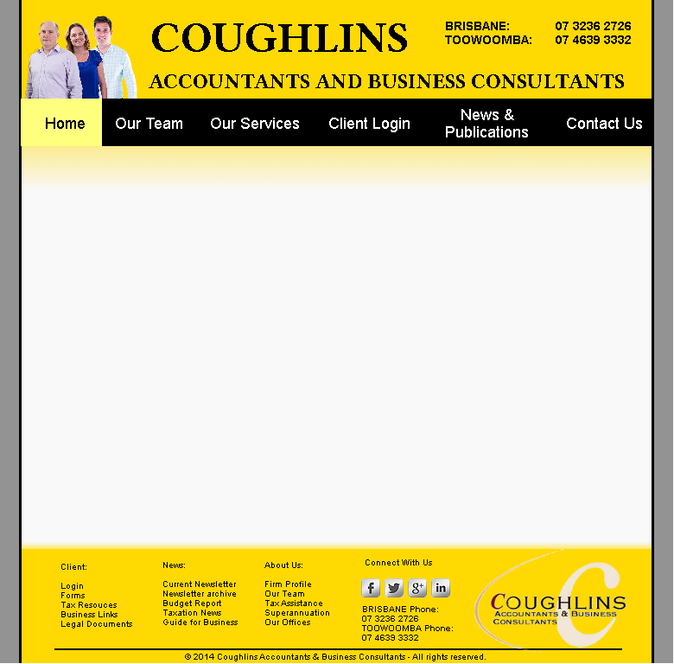

Here is the first half of the homepage. The second half of the homepage will be an example of the “Dual column” text presentation.

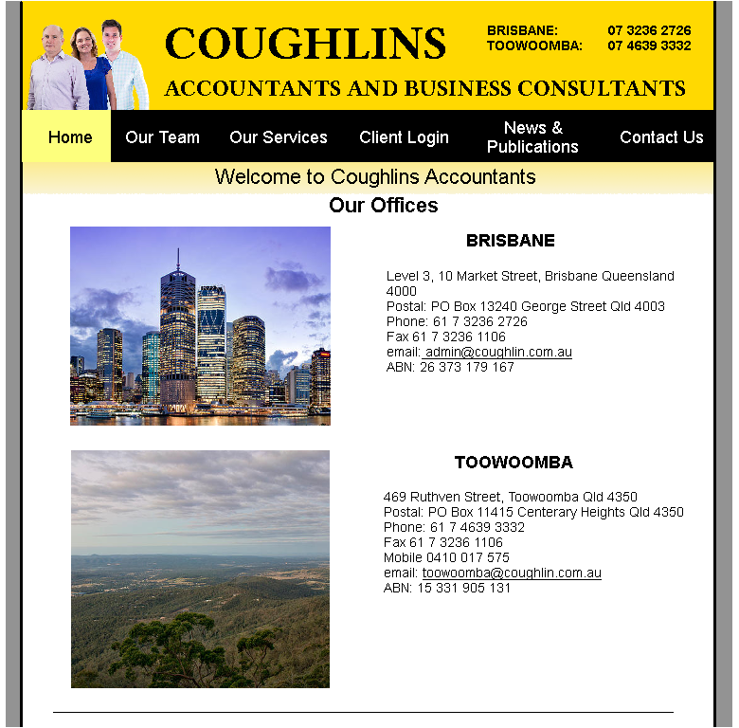

Here is the second half of the homepage and it talks about Coughlins identity and what they have to offer. It also displays the two ways we’ll be displaying text on this website. With a combination of cross page text and two column bullet points, this is the template for any articles we’ll link to.

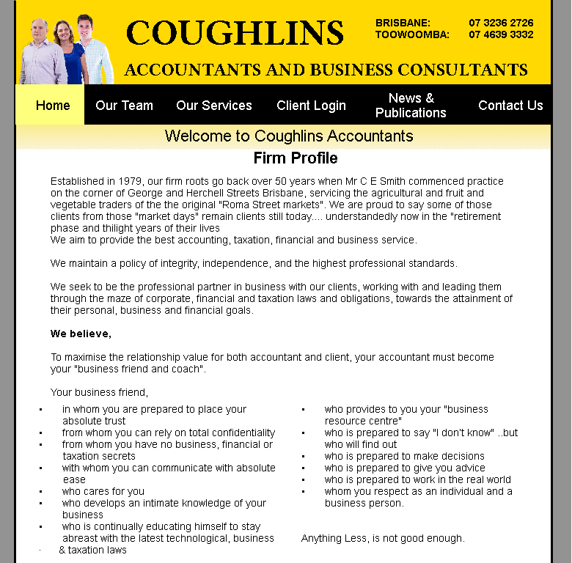

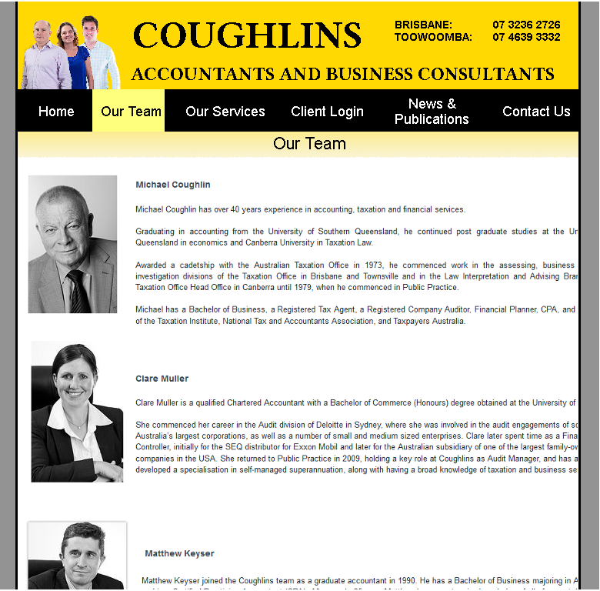

Here we see an example of our sub-navigation. Each of the links on this page will link to text displayed like in our article-style page. Any footer navigation that does not link directly to an article, will link to a sub-navigation page like this and scroll to the corresponding heading.



Here we demonstrate the way we’ll display PDF’s on the site. Any link from footer navigation will redirect to a page like this. When you click “View PDF” the browser’s inline pdf viewer will handle it, if the browser has no inline pdf viewer the pdf will download instead.

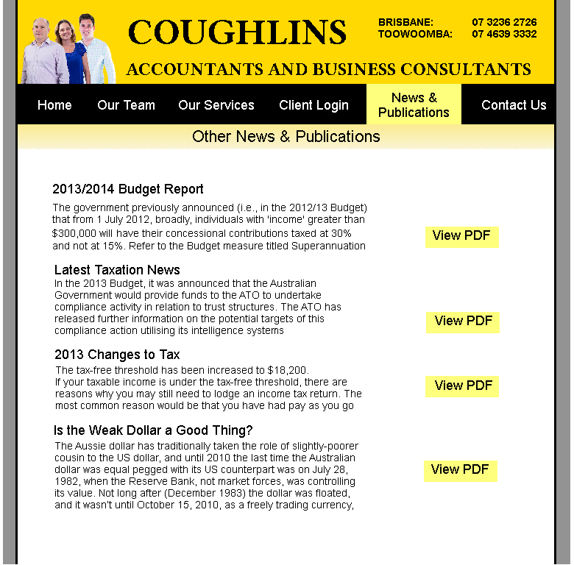

The Newsletter section is treated a little differently to the rest of the PDFS. We have only slightly modified the layout here, getting rid of the blue text, turning the headings black and moving the “view more” button up with the main body of text. The Newsletter archive is completely unchanged apart from minor colour adjustments as the layout is just fine. With footer and header navigation leading there it’s redundant to also have in-page navigation to the newsletter archive so it was removed.

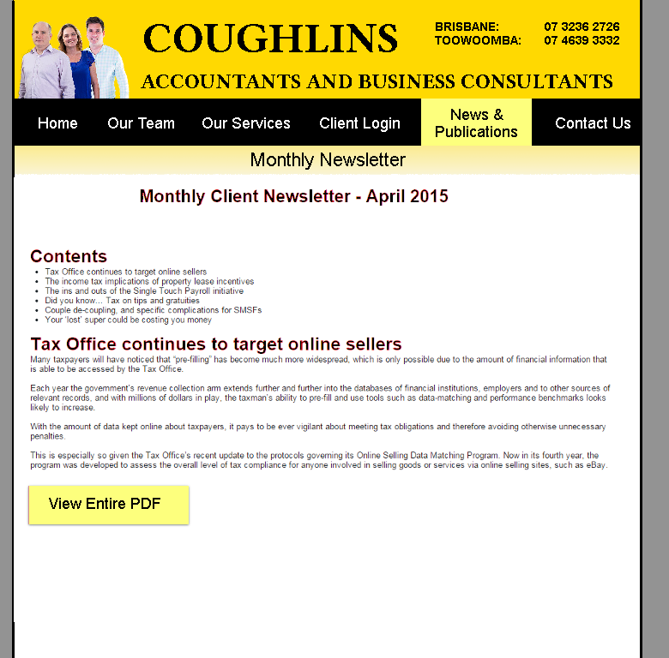

In the original site, the client area is a place filled only with external links and is also unclear to be a link to a normal user. To resolve this problem, we have made it easier to interpret whether the user will be linked externally and turn the page into a useful resource. This helps self-motivate the potential clients so they can get on top of their taxes. By making it a useful resource, the following links are present; DropitIn, Law Central, MYOB, Symantec antivirus, and various others. The user only has to click on the image to load the external site.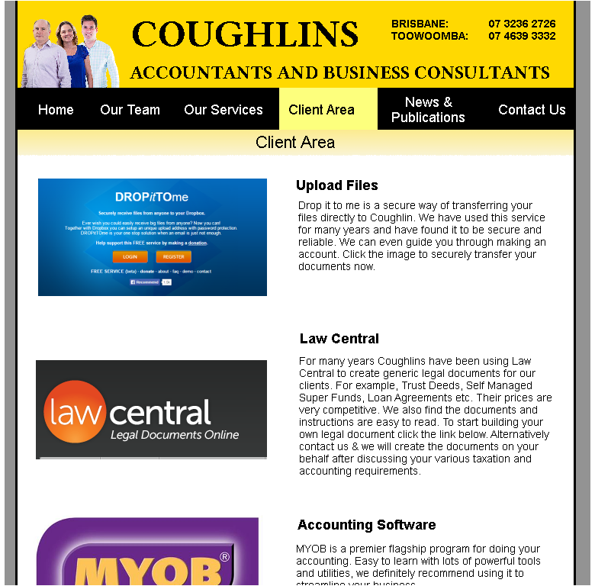

# Design Rationale & Conclusion

Overall, the redesign of website has implemented the resulted recommendations that were in the analysis of the site. One of the recommendations that was to be highly considered was the colour scheme throughout the website. Previously, the use of colours red and white were used, which made the website hard to read (in different contrasts) and difficult to interpret important information due to excessive use. The new colour scheme, implementing black and yellow, has portrayed the website to look professional and eye-catching to the users. This is highly advisable for a growing local business, like Coughlins, whom are seeking professionalism to be overseen through their website.

In addition, there were functionality issues that were present throughout the site (refer to recommendations). These issues have been resolved with the use of textboxes and layout alterations, which can be seen in the visual mock-ups. One of the key benefits for targeting the functionality of the site is that it will ensure users possess minimal issues upon using the website.

Lastly, the redesign of the site has also taken into consideration simplicity, which is essential for maximizing potential users and keeping current users. The previous layout of the Coughlins website can be difficult to interpret from a user’s point of view and leaves them questioning their involvement with the business. As a result, changes were made to the layout of the site to make it appear desirably simple (refer to mock-ups) and avoid users from becoming frustrating. This not only creates a more pleasant website experience for users, but it ensures that Coughlins is maximising its potential customers with the use of their website. Therefore, by performing these recommendations stated previously, the redesign of the site will meet the needs and standards of both the business and its customers.

The redesign has taken into account that people are looking for an accounting firm that looks very reliable. An organized and easy-to-use website will not only tick the criteria of this in the personae’s, but it will also achieve a sense of reliability that users will gather from the site. Furthermore, it is clear that clients are looking for an accounting firm that can be trusted and have plenty of experience in their belt. The redesign of the site ensures that this is encountered for by portraying the owner’s image and experience in the site. Overall, the redesign was based off the personae’s in order to create the most productive and user-friendly website for a growing accounting business.